BlockChain – The Open Economy

*By P.* *Jitendra Kalyan, BE 3/4 CSE-2*

Say we were sitting in a cafe and I gave a document to you. I physically gave it to you and you took it. You know that you may give something to your friend as you wish. Now imagine a scenario in which I gave a digital document to you over some service provider. What is the proof that I did not give that document to my friends, or that I didn’t save copies of it with me? What are the chances that the so-called service provider did not take copies of it or that the exact document that was sent was received by you? This mistrust is the problem with a middleman being the provider of a service. Nobody knows what is happening with the document except for the owner, nobody will have any clue if the owner decides to add new documents. This is the working nature of proprietary services.

Imagine a system where a ledger is maintained to count the number of documents being made and sent. Now we can keep track of the documents. What if the ledger is made **open to everyone**? Every other user in the network will have the same ledger and any differences in ones ledger can be sorted out *(means no cheating!)*. If you add new documents by solving a problem, you will be awarded with some documents for yourself for the effort you've put in.

Similar to the above story, the centralised service is the present banking system where no one actually knows what is happening. The ledger solution in the story was given by BlockChain.

source : warranteer.com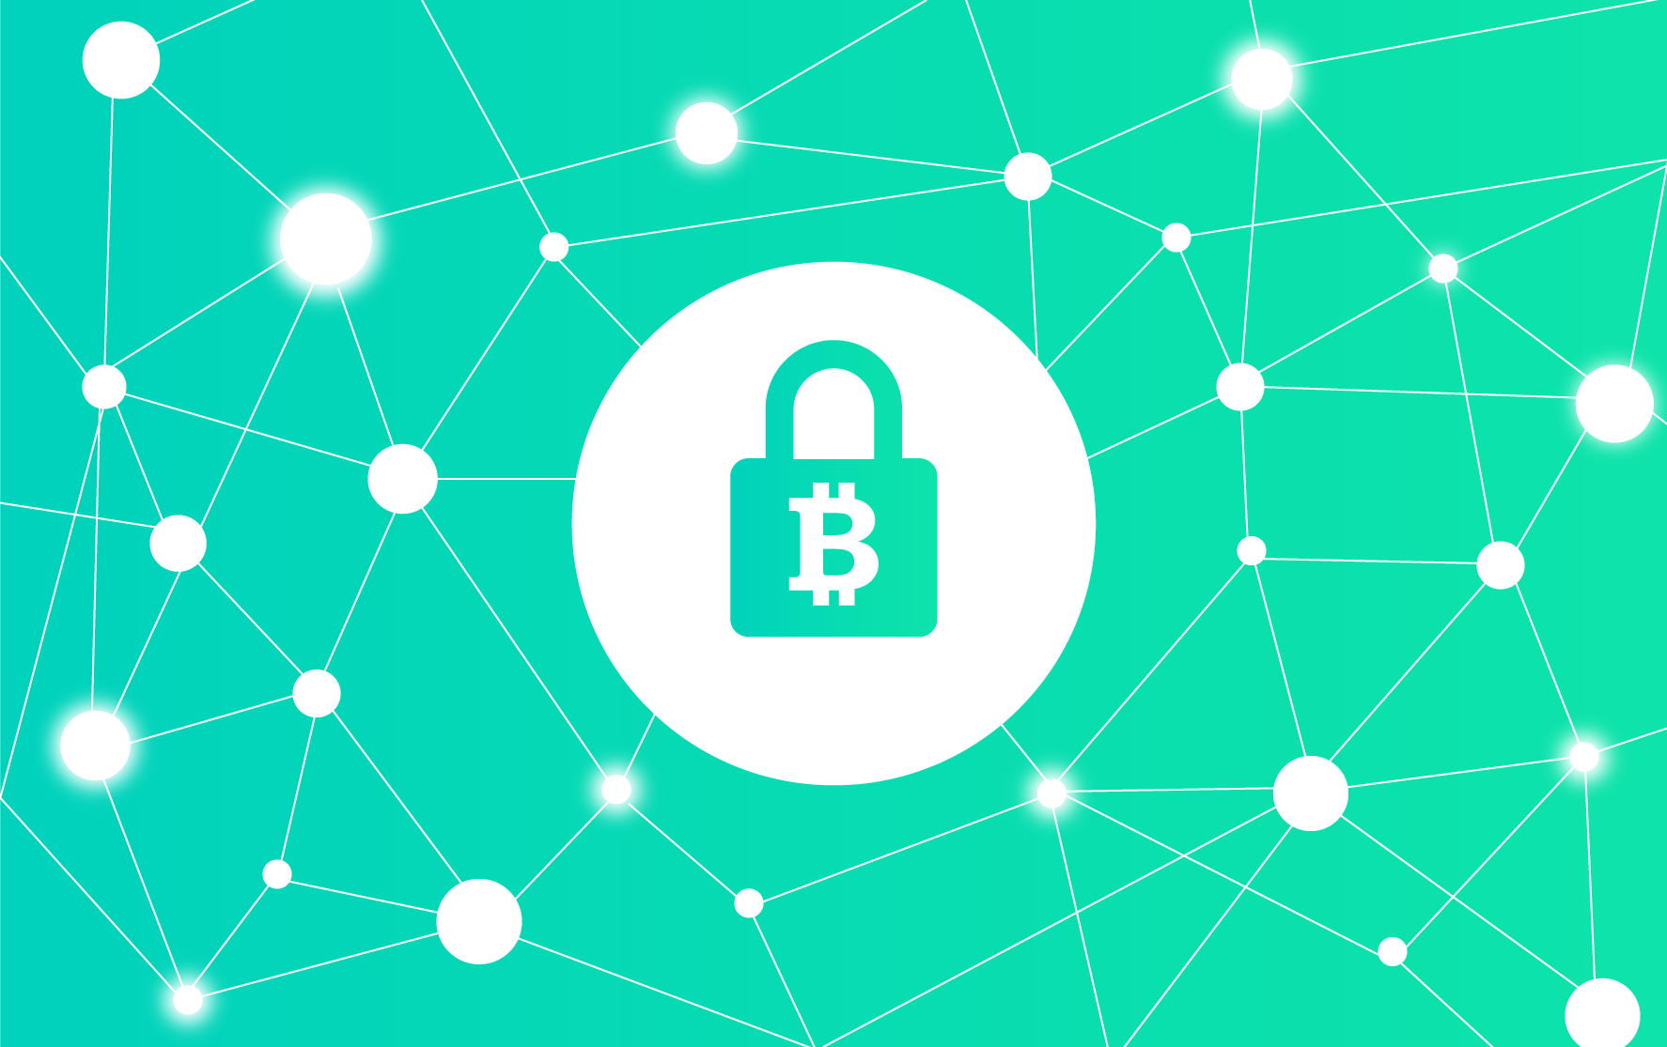

*What is BlockChain?*

“Its a software solution that keeps track of all the digital assets of users”, by definition.

*How does BlockChain work?*

*1. Transparency:* All the users will own the details of every other transaction happening in the network, which basically adds trust to the system.

*2. Openness:* It is not controlled by a single authority or person. The power of BlockChain lies in the potential number of users there are in a network. It follows the rules of opensource.

*3.Security:* Each transaction is done cryptographically with strong encryption. The transaction will pass through every adjacent block (shown in figure).

*4.Cryptocurrency:* BlockChain uses the digital currency known as ***Bitcoin,*** which can be encrypted using cryptography. The document in our story is bitcoin (digital currency).

*5.Earning coins:* In order to earn new coins you would need to solve problems which are mathematically very tough and algorithmically hard. New coins will be added only when problems are solved.

The advantage of using BlockChain and bitcoins is the efficiency that this technology can offer with the added advantage of transparency. The world is converting to a digital space, and its time we shift our economy to an open, reliable, and secure digital platform.